Software Engineer Technical Challenge

The challenge, should you choose to accept it, is to create a simple client-server system to search for and display a list of equipment records. We expect this challenge to take around four hours of working time, but typically one week is allowed for submission.

The client is to be implemented as a single HTML and JavaScript page. Figure 1 provides a screenshot of the requested layout.

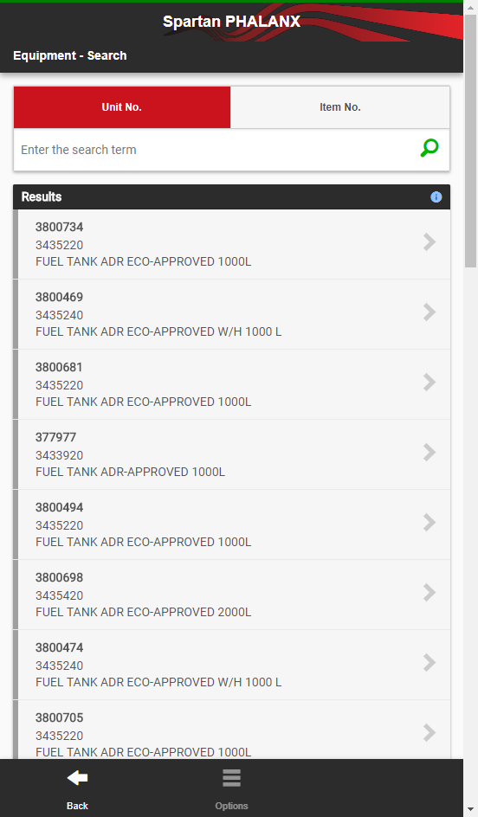

Figure 1 Client Screenshot

The server will (at a minimum) consist of a single endpoint to allow equipment records to be queried by unique identifier (i.e. Unit No.). If time permits a second endpoint may be included to allow searching by equipment type identifier (Item No.).

A separate JSON data file is provided (EquipmentData.json) which contains equipment and equipment type records. Endpoints may need to transform data into an a more appropriate structure for display in the client.

Some additional points to consider:

1. The server will preferably be implemented in ASP .NET Web API in Visual Studio, although we will accept other implementations if there are legitimate reasons.
2. The client layout in Figure 1 is the ideal, but functionality should be prioritised over look and feel. For example, exact colour matches and icons are not overly important. The ‘wave’ image in the header is not required.
3. The JSON file must not be altered.
4. Use any libraries you need to complete the challenge.

Your solution should be managed in a git repository, a link to which is to be submitted at the end of the permitted week.

Good luck!